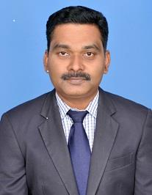

Dr.P.Selvaraj ME,PhD